

Data Science Program

Capstone Report - Fall 2025

Smart School Food Service Analytics: AI-Driven Demand Forecasting and Waste Reduction Using Fairfax County Public Schools Data

Jupiter Kang,
Crystal Kao,
Alonso Romero

Supervised by
Dr. Amir Jafari
Abstract
Food waste in U.S. public schools presents a significant economic and environmental challenge, with approximately 530,000 tons of food discarded annually, resulting in $1.2 billion in losses. Fairfax County Public Schools (FCPS) in Virginia seeks to address this issue by leveraging data-driven insights to optimize their food service operations. Despite widespread availability of digital data from Point-of-Sale (POS) systems and kitchen production records, most districts—including FCPS—lack the analytical tools necessary to effectively utilize this information. This project analyzes FCPS data from March to May 2025 to uncover patterns in food consumption, identify inefficiencies, and recommend actionable strategies for reducing waste. Key research objectives include evaluating a la carte item popularity at the school level, assessing participation trends through year-over-year comparisons, and segmenting data by FCPS regions and High School Pyramids. Through advanced data analytics, this study aims to support FCPS in making informed, efficient, and sustainable decisions for school meal planning and delivery.
Contents
1 Introduction 4
2 Problem Statement 4
3 Related Work 4
4 Solution and Methodology 4
5 Experimentation and Results 4
5.1 Experimentation Protocol 4
5.2 Data Tables 5
5.3 Graphs 5
6 Discussion 7
7 Conclusion 7
8 Bibliography 7

1 Introduction
School food service operations face mounting pressure to deliver nutritious meals while minimizing waste and controlling costs. In the United States alone, school districts collectively waste an estimated 530,000 tons of food annually—equivalent to $1.2 billion in economic losses, according to the USDA. These inefficiencies are often the result of outdated management practices that rely heavily on manual forecasting, static menus, and experience-based decision-making. As student populations grow more diverse and operational demands more complex, school systems urgently need intelligent, data-driven solutions to optimize meal planning, procurement, and production.
Despite the increasing availability of digital data from Point-of-Sale (POS) systems and kitchen production records, most school districts lack advanced analytics tools capable of integrating and analyzing this information in a meaningful way. To take initiative in solving this problem, Fairfax County Public Schools (FCPS) reached out and provided data for March to May of 2025.

2 Problem Statement
Food Waste in U.S. public schools has been a major issue, and Fairfax County Public Schools (FCPS) in Virginia wants to find ways to reduce food waste for their county. These are the following questions that will be answered through this project as provided by the client:
- A La Carte Sales – specific to school or item (to see how popular each item is)
- Average Daily/Weekly/Monthly participation in year-over-year comparison to quickly assess when schools are falling below baseline or quickly rising
- Separating the data sets by our FCPS regions and High School Pyramids

3 Related Work
In addition to data driven solutions, some other schools around the country have also taken to behavioral interventions that could be interesting for FCPS to also consider. Some interventions being implemented included announcing milk is not mandatory, taking back unpeeled fruits and unopened packaged food. They also did classes on what happens to food waste and how it affects the environment (https://thefern.org/2024/06/the-cafeteria-as-classroom/). Other research teams also looked into what kinds of foods were being wasted the most to better target a solution. They found that fruits and vegetables went to waste most often, while eggs and poultry were the least wasted food category (https://www.psu.edu/news/research/story/us-school-cafeterias-waste-more-food-those-other-developed-countries).

4 Solution and Methodology
[The solution section covers all of your contributions (architecture, algorithms, formulas, findings).
It explains in detail each contribution, if possible, with figures/schematics.
Don't forget that a figure goes a long way towards helping your reader understand your work.
For instance, Figure 1 outlines the layers involved in a distributed certification service, and how
they articulate together. Nevertheless, a figure must always come with at least one paragraph of
explanation. The rule is that anyone should be able to understand your solution from reading
the text in this section, even if they skip the figures.]

Optimization Methodology
For our optimization model, we used Linear Programming. This method optimizes a linear objective under linear constraints, through two ways, regular linear programming and integer linear programming. Linear programming allows fractions to be considered, whereas linear programming enforces whole numbers. The results from integer programming optimization are more realistic in this case as schools provide menu items as a whole and not a fractional split. The optimization formula used is as follows:
$$min \sum_{s}{}\sum_{j}{}c_{j}x_{sj}$$
Where s is the individual school, j is the meal type (i.e. breakfast or lunch), and $c_{j}={\underline{c}}_{j} + 0.1 ⋅waste penalty_{j}$ and ${\underline{c}}_{j}$ is the average unit cost.
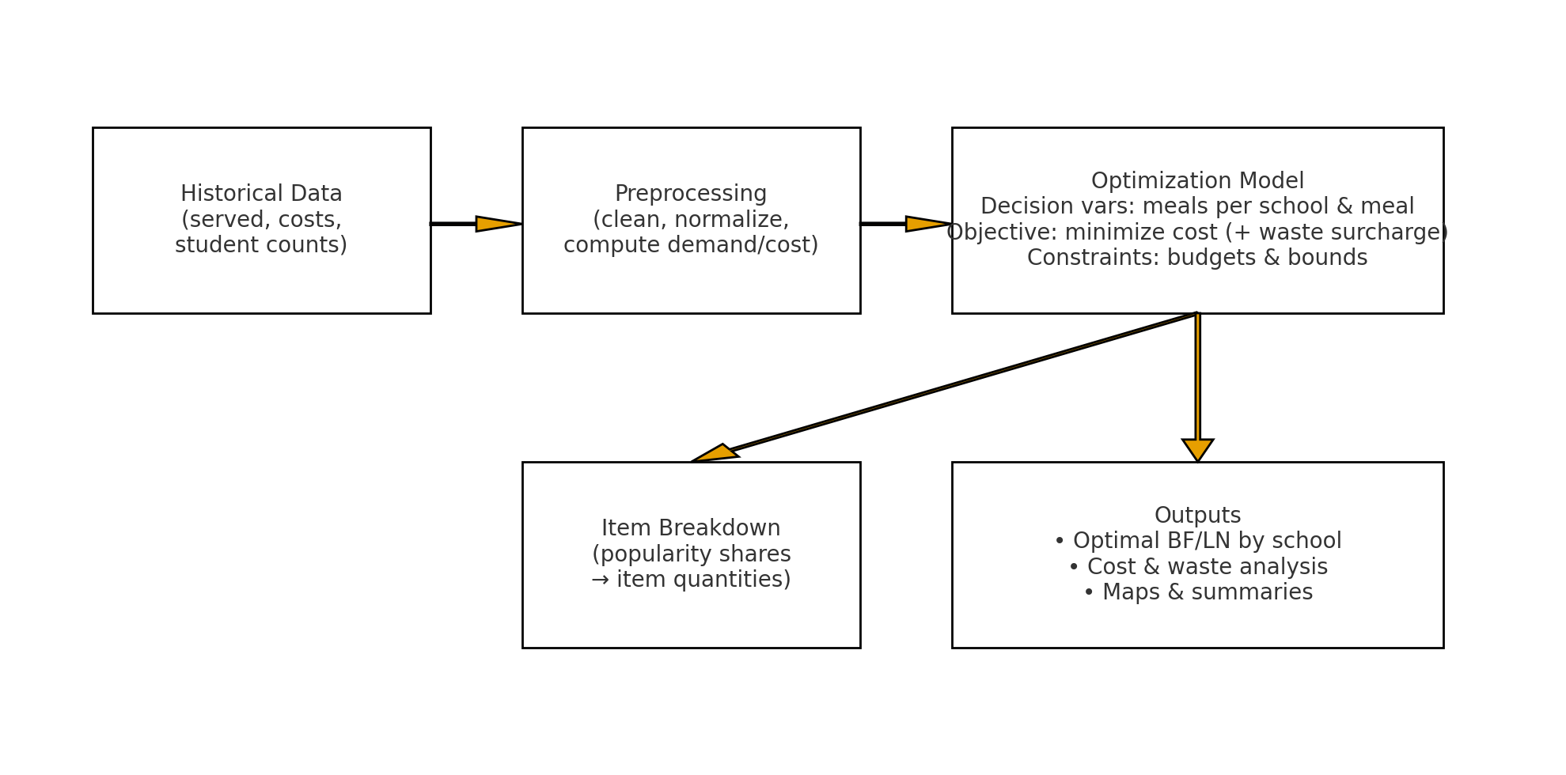
Figure #: Optimization pipeline schematic
The user provides the model with historical data. In this case, we have provided data for consumption and waste data for breakfast and lunch for all the schools in the system; sales data of menu items across all the schools; individual school student population data; and nutritional information of all the menu items served to students.

5 Experimentation and Results

5.1 Experimentation Protocol
[It is of the utmost importance to describe how you came up with the measurements and results
that support your evaluation.]
Average Daily Demand: Calculates the day-by-day average of each individual menu item demand from all the schools in the school system. The formula is represented as:
avg_bf_demand =$\frac{Σ Served reimbursable}{\# of days}$ avg_ln_demand = $\frac{Σ Served reimbursable}{\# of days}$
Average Unit Cost: Calculates the average production costs of making the meals for the breakfast and lunch for the schools in the system. The formula is represented as:
${\underline{c}}_{BF} = \frac{Σ production cost total}{Σ served reimbursable}$ ${\underline{c}}_{LN} = \frac{Σ production cost total}{Σ served reimbursable}$
Unit Cost (input): Calculates the unit cost that would be used as input to the solver. Where 0.1 is the fixed weight in the code, j is for the meal type, and the waste penalty is the per-meal parameter that will be passed. The formula is represented as:
$$c_{j} = {\underline{c}}_{j} + 0.1 ⋅waste penalty_{j}$$
Optimizer: The main model that will be determining the amounts of menu items to produce per meal period for each school.
$$x_{sj}$$
The formula in figure # represents where the model keeps the production cost low, but also considers the waste risk. After the calculation, it provides a waste analysis, which compares production to expected demand, but it does not dynamically penalize the $max(0, x_{sj} - demand_{sj})$. The model incorporates a fixed waste surcharge into the cost component $c_{j}$. This surcharge is given by the expression $0.1 ⋅waste penalty_{j}$. For true waste minimization, constraints are introduced to the model.

Budget Constraint
To make our model provide realistic results, we have considered a budgetary constraint. Fairfax County Public Schools allocates a dedicated amount to the Food and Nutrition Services from its overall annual budget.
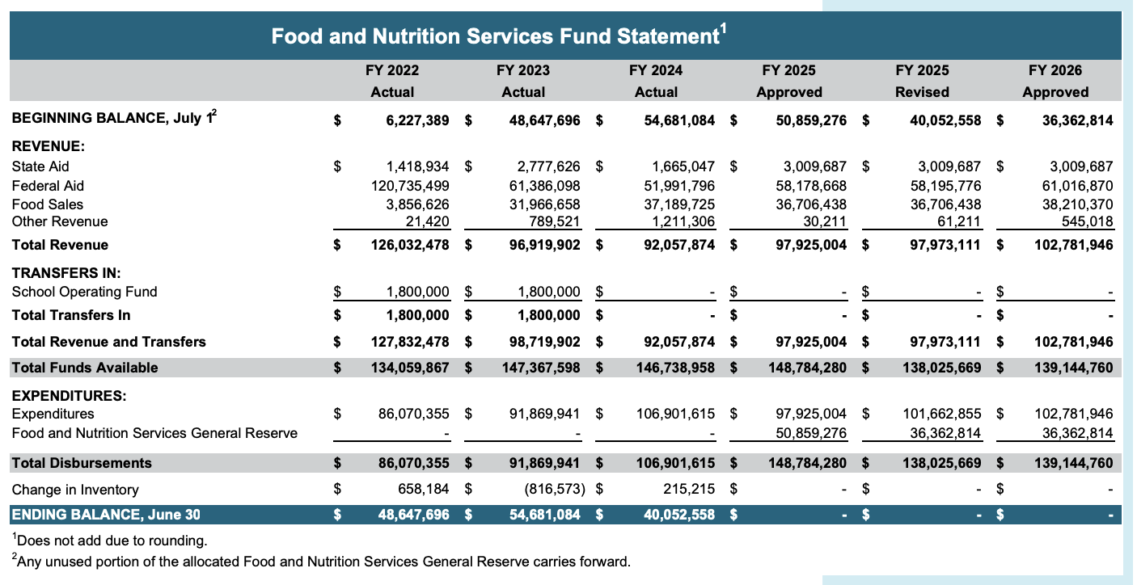
Table #: Food and Nutrition Services Fund Statement from FCPS’ 2026 Approved Budget document
When determining the budget for the optimization model, the value was used based on the 2026 approved budget total funds available value. This value was what the Food and Nutrition Services had to work with, so this provided a realistic target for the optimization model.
For our analysis, we provided two different budgetary constraints. The first budgetary constraint is a per-school budget, which allocated the Food and Nutritional Services Funds to each of the 109 schools in the system. Specifically, for every single school, the total cost of all meal types must be less than or equal to that school’s specific budget. This represents the following inequality:
$$\sum_{j}{}{\underline{c}}_{j}x_{s,j} ≤ B_{s} ∀s$$
The second budgetary constraint is for the whole school system budget. This constraint states that the grand total cost of all meals, for all schools combined, must be less than or equal to the total budget for the entire school system. This represents the following inequality:
$$\sum_{s}{}\sum_{j}{}{\underline{c}}_{j}x_{s,j} ≤ B_{total}$$
Production Bounds Constraint
Along with a budgetary constraint, a production bounds constraint is considered. This constraint provides a limit of production to be reached based on the demand.
$$L_{s,j} ≤ x_{s,j} ≤ U_{s,j}$$
The bounds are determined based on the model. When using the Linear Programming and Integer Linear Programming optimization models, the bounds are passed directly in the code. For the size-based optimization model, the bounds are demand scaled by size multipliers based on the student population size of each school. For example, the bounds for a medium sized school is (0.95, 1.05), which is represented by:
$$L_{s,j} = 0.95 ⋅demand_{s,j} U_{s,j} = 1.05 ⋅demand_{s,j}$$

5.2 Data Tables
[Every data table should be numbered, have a brief description as its title, and specify the units used]

5.3 Graphs
[Graphs are often the most important information in your report; you should design and plot
them with great care. A graph contains a lot of information in a short space. Graphs should be
numbered and have a title. Their axes should be labelled, with the quantities and units specified.
Make sure that individual data points (your measurements) stand out clearly. And of course, always associate your graph with text that explains your results, and outlines the conclusions you draw from these results.]
Optimization
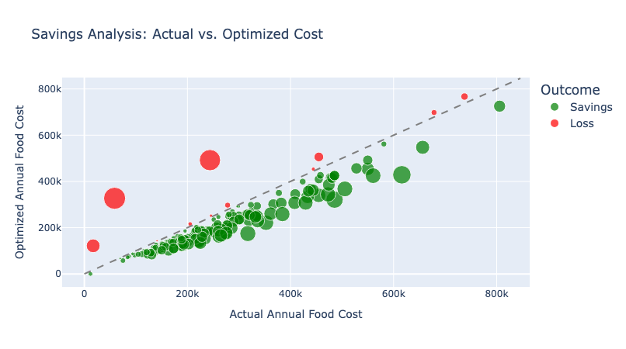
Figure #: Bubble graph of the savings analysis between actual and optimized production costs
Figure # compares the results of the savings between actual and optimized production costs for each individual school in the Fairfax County Public School system. The dashed line going across represents the zero mark where there would be no money being saved. Datapoints below the line represent the schools that are saving with the optimization model, where the bigger the bubble, the bigger the savings. Datapoints above the line represent schools that are losing money with the optimization model, where the bigger the bubble, the bigger the loss is. The figure shows that the majority of the schools are showing positive results with the optimization model, whereas 11 schools are showing negative results.

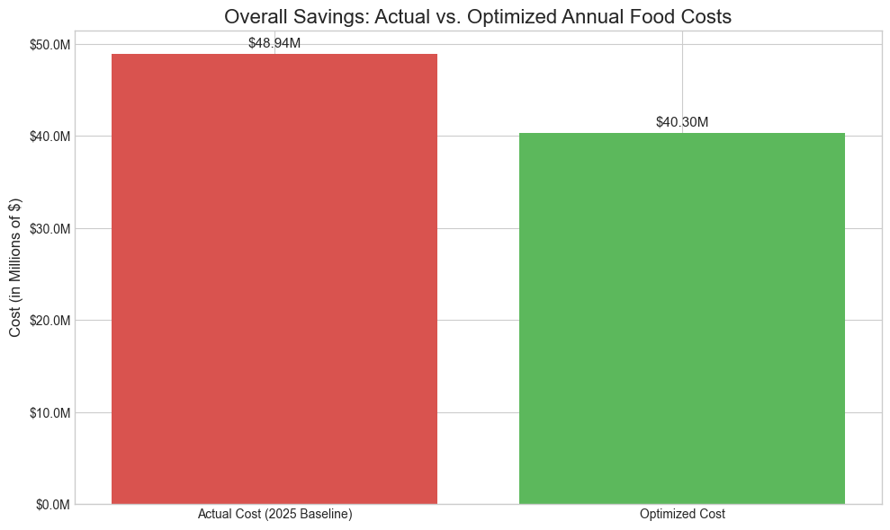
Figure #: Bar graph of overall savings: actual vs. optimized annual food costs

Despite there being schools resulting in losses in the optimization model, figure # shows that overall, the optimization model is providing savings of about $8.6 million.

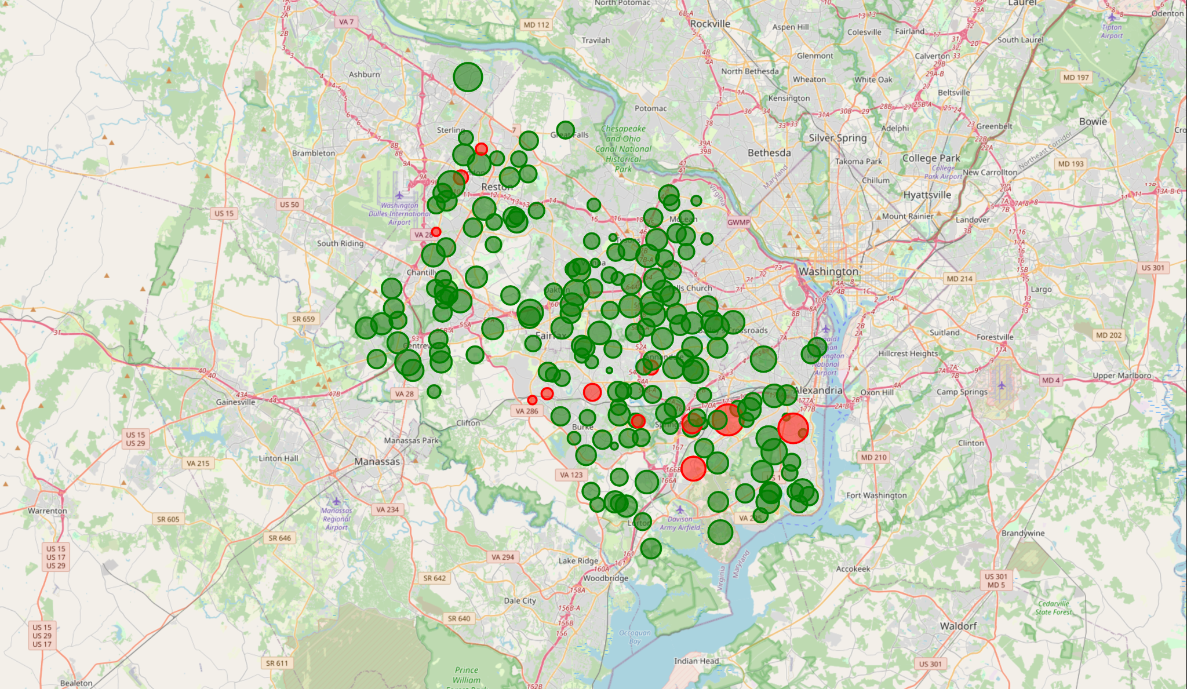
Figure #: Geographical map of Fairfax County with bubbles representing the schools

Figure # provides another version of the bubble graph where green bubbles represent schools saving money from the optimization model and red representing those that are losing money from the optimization model. Through the use of a geographical map, we can observe which regions of the FCPS system contain the schools producing losses to see any trends.

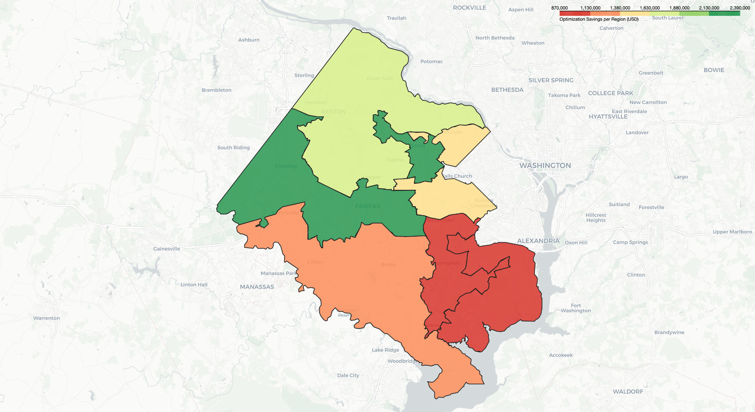
Figure #: Choropleth map of Fairfax County highlighting savings amounts from optimization

6 Discussion
[The discussion section focuses on the main challenges/issues you had to overcome during the project. Outline what your approach does better than the ones you mentioned in your related work, and explain why. Do the same with issues where other solutions outperform your own. Are there limitations to your approach? If so, what would you recommend towards removing/mitigating them? Given the experience you've gathered working on this project, are there other approaches that you feel are worth exploring?]

7 Conclusion
[Give a clear, short, and informative summary of all your important results. Answer the initial
question(s) or respond to what you wanted to do, as stated in your introduction. It can be a
short table or a list, and possibly one or two short comments or explanations.
Target a reader who may not have time to read the whole report yet, but needs the results or
the conclusions immediately. This is a typical situation in real life. Some readers will read your
introduction and skip to your conclusion first, and read the whole report only later (if at all).
You may also draw perspectives. What's missing? In what directions could your work be
Extended?]

8 Bibliography

